PropPlaceback Script Documentation

The PropPlaceback and variables scripst are C# scripts that are attached to a game object in Unity. The purpose of these scripts is to handle the fade-in and fade-out effect of a see-through material when a target object is placed within a specific trigger zone. The script utilizes a reference to the variables script, a see-through material, and two coroutines to achieve this effect.

1. Variables
2. Methods
3. Code Explanation
4. How to set up the script and prefabs to work properly
5. Conclusion

1. Variables

public GameObject TargetObject: This variable is a reference to the object that the script needs to detect in order to trigger the fade effects.

public bool IsInPlace: This bool changes depending on if the TargetObject is in the collider or not.

[SerializeField] private PropPlaceBackVariables propPlaceBackVariables: This variable is a reference to the variables script that contains data about the target object and whether it is in place or not.

[SerializeField] private Material SeeThroughMaterial: This variable is a reference to the see-through material that will be faded in and out when the target object is in place or not.

[SerializeField] private float fadeTime = 0.1f: This variable is the time it takes for the material to fade in or out.

[Range(0f, 0.5f)] private float AlphaValue: This variable stores the current alpha value of the see-through material.

2. Methods

void Start(): This method is called at the beginning of the script execution. It sets the starting alpha value of the see-through material and stores it in the AlphaValue variable.

void OnTriggerEnter(Collider other): This method is called when the target object enters and stays within the trigger zone. It sets the IsInPlace variable to true in the variables script and starts the FadeOut coroutine to fade out the see-through material.

void OnTriggerExit(Collider other): This method is called when the target object exits the trigger zone. It sets the IsInPlace variable to false in the variables script and starts the FadeIn coroutine to fade in the see-through material.

IEnumerator FadeOut(): This coroutine fades out the see-through material by decreasing the alpha value over time until it reaches zero.

IEnumerator FadeIn(): This coroutine fades in the see-through material by increasing the alpha value over time until it reaches 0.5.

Bovenkant formulier

3. Code Explanation

The script starts by setting the Materials alpha value of the material to 0.5 and assigns the Materials alpha to the AlphaValue float in the Start() method.

In the OnTriggerEnter() method, the script checks if the predefined target object is inside the Trigger Collider, and sets the IsInPlace bool to true, writes a debug log, snaps the furniture to the Scripts parent object’s position, and Starts the FadeOut() coroutine. Afbeelding met tekst

In the OnTriggerExit() method, the script checks if the predefined target object has left the Trigger Collider, and sets the IsInPlace bool to false, writes a debug log, and Starts the FadeIn() coroutine.

In the FadeOut()/FadeIn() coroutines, the script changes the AlphaValue and changes the SeeTroughMaterial alpha, so that it either becomes invisible, or becomes transparent again.

4. How to set up the script and prefabs to work properly

To start off, copy the transform values of the furniture piece you want to use for the placeback feature.

Drag the NamePlaceback prefab into your scene and paste in the transform component values

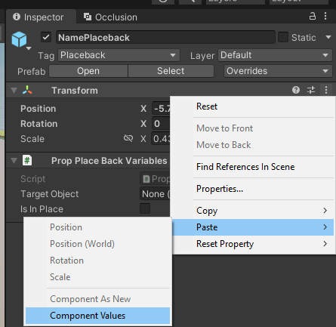

Rename the NamePlaceback prefab to the name of the furniture, in this case FridgePlaceback, and unpack the prefab entirely

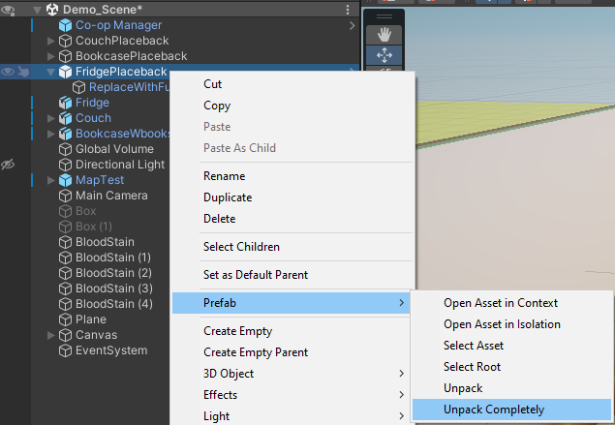

Copy the furniture piece and paste it as a child into the Placeback parent.

Remove the copied furniture piece’s rigidbody and box collider if they are present. Copy all the components of the ReplaceWithFurniturePropAndAddSeeTroughMat and paste them onto the copied furniture. You can remove ReplaceWithFurniturePropAndAddSeeTroughMat after.

Create a new material using the SeeThroughProp shader. And assign it to the copied furniture object

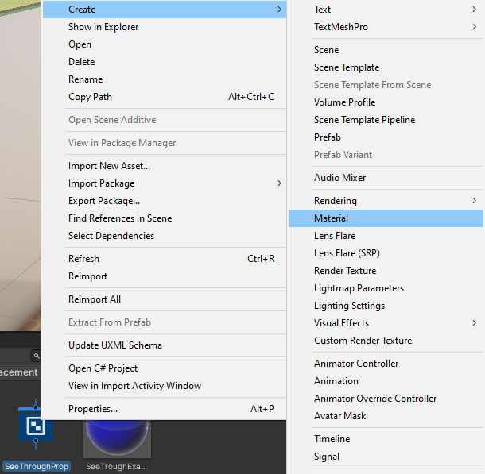

The furniture object should look like this in the inspector:

In the Placeback parent and child objects, assign and do the following things:

On the parent object, The Target Object is the original object that is being detected wether it has been moved into the placeback collider. Also change the Tag to “Placeback”

On the child object, Turn off the shadows

Assign the PropPlaceBack variables script and the seethrough material you assigned to the furniture piece.

Make the Mesh collider convex and make it a trigger

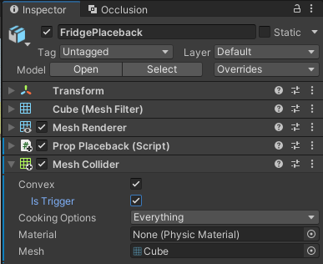

Set the color of the shader to whatever you want, Set Metallic to 1 and set the Alpha to 0.5

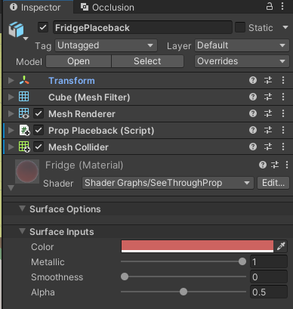

Now test out the feature and enjoy :).

5. Conclusion

Overall, the PropPlaceback script is a useful tool for creating dynamic effects within Unity games. Its ability to fade materials in and out based on specific conditions can enhance the player's experience and create a more immersive environment.